
PYTHON PROGRAMMING LAB FILE

Name: Krishna Som
Sap ID: 590025475
Batch: 34
Teacher: Sugandha Sharma

Experiment 5
Objective 1: Scan n values in range 0-3 and print the number of times each value has occurred.
Code:
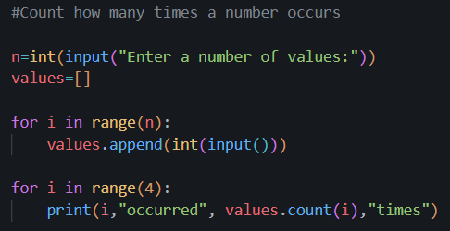
Output:
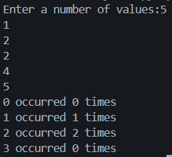

Objective 2: Create a tuple to store n numeric values and find average of all values
Code:
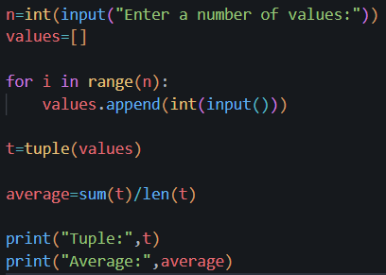
Output:
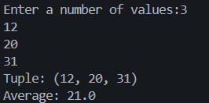

Objective 3: WAP to input a list of scores for N students in a list data type. Find the score of the runner-up and print the output.
Code:
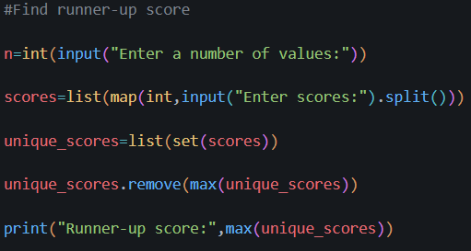
Output:
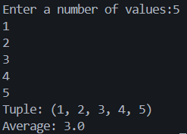

Objective 4: Create a dictionary of n persons where key is name and value is city.
a) Display all names
b) Display all city names
c) Display student name and city of all students.
d) Count number of students in each city.
Code:
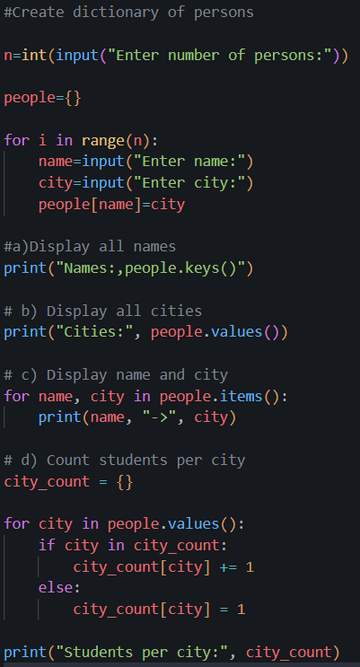

Output:
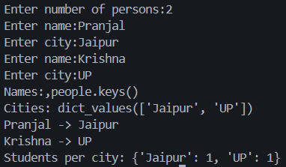

Objective 5: Store details of n movies in a dictionary by taking input from the user. Each movie must store details like name, year, director name, production cost, collection made (earning) & perform the following :-
- print all movie details
- display name of movies released before 2015
- print movies that made a profit.
- print movies directed by a particular director.

Code:
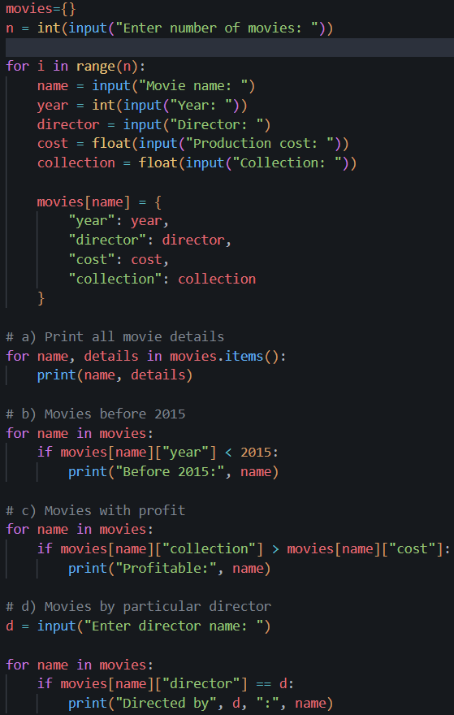
Output:
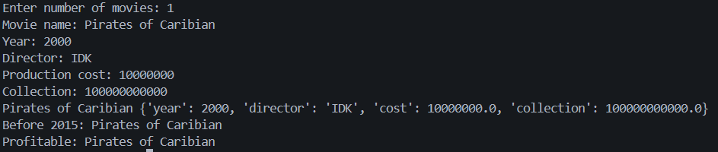

Objective 6: Create a contact book where users can store, search, update, and delete contacts. Use dictionary for storing contacts
Code:
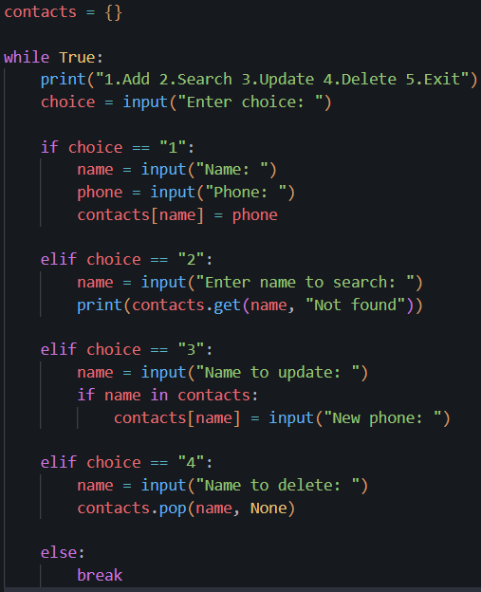

Output:
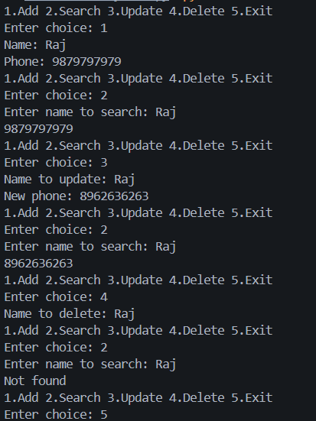

Objective 7: Create a Todo list Manager where users can add, view, and remove tasks. Use List for storing tasks.
Code:
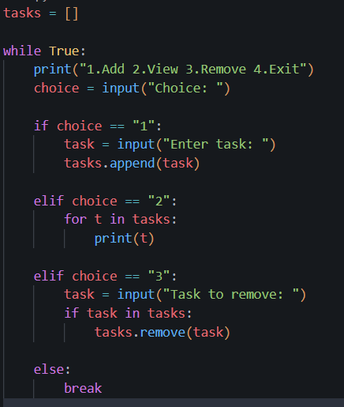
Output:
